**Question 1. What is application packaging?**

* **Application Packaging:**

Application packaging is a type of formatting our software in such a way that it can be easily installed, managed, and uninstalled.

To deploy and use software, we require various useful files such as a settings file, configuration, permissions, etc. To combine all these files, we do application packaging.

Here are some packaging formats:

* **For Windows**:

1. .exe: common executable installer
2. .**msi** (Microsoft installer): standard for Windows applications
3. .**app-V** (Application virtualization): apps run in an isolated environment
4. .**msix**: modern packaging format replacing .msi and .app-V

* **End-to-end packaging process**:

It consists of three steps:

1. Application discovery
2. Application packaging
3. UAT

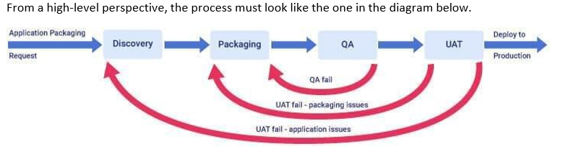

**Question 2. Steps to install MSIX**

* **How to install the MSIX packaging tool**:

1. Go to the Microsoft store
2. Search for the MSIX packaging tool
3. Click install.

* **Steps to install MSIX:**

**Step 1**: Get the MSIX Package

Download the **.msix** file

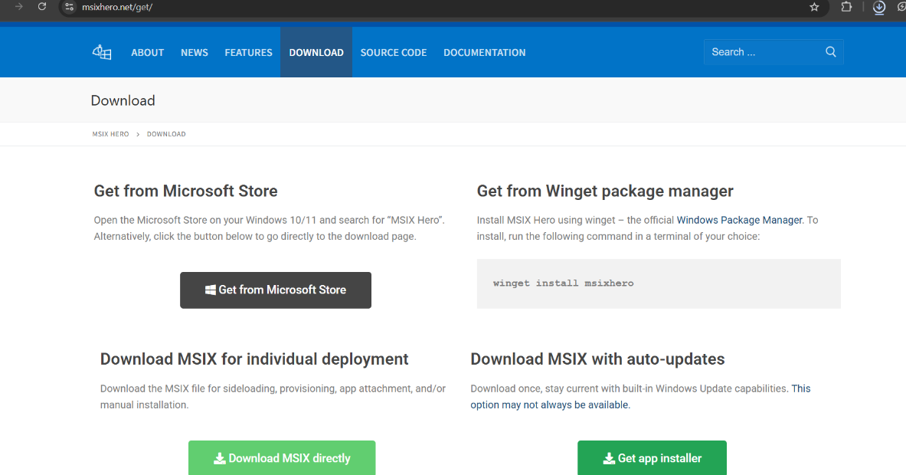

**Step 2**: Double-click the File

On **Windows 10/11**, just **double-click the .msix file**.

You’ll see a simple **installer window** showing:

* App name
* Publisher
* Version

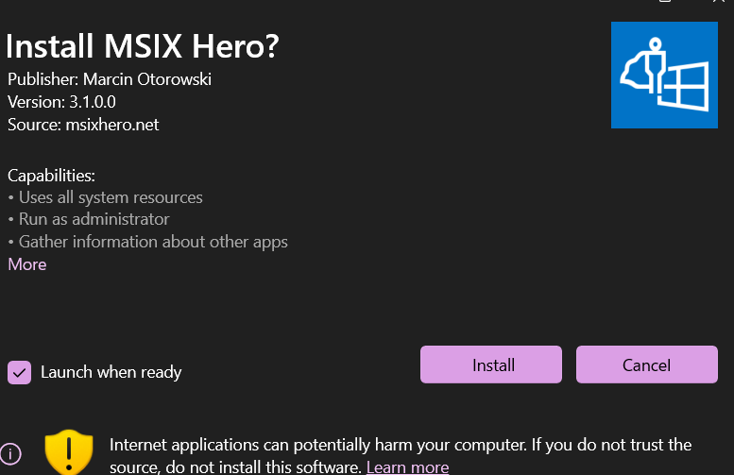

**Step 3: Click Install**

* Click the **Install** button.
* Windows will install the app and place it in the **Start Menu**.
* The app runs in a **sandbox** for better security.
* **Alternative (PowerShell):**
* If double-click doesn’t work, use PowerShell:

**Command**:

**Add-AppxPackage -Path "C:\Path\To\YourFile.msix"**

